| **Test Name** | | Successful login | | | |
| --- | --- | --- | --- | --- | --- |
| **Use Case Tested:** | | Use Case 13 – Log in | | | |
| **Test Description:** | | User wishes to enter an error.  User enters a valid username.  User enters a valid password that relates to the username.  User selects Submit button.  User is presented with the Enter an Error page. | | | |
| **Pre-conditions** | | A valid user name and password exists for user | | | |
| **Post-conditions** | | Enter an Error page is presented to user for completion  User will only have Log Out option available in the menu bar | | | |
| **Notes:** | | *Screenshots relating to test can be found after the Test Data Table* | | | |
| **Result (Pass/Fail/Warning/Incomplete)** | |  | | | |
|  | **TEST STEP** | | **EXPECTED TEST RESULTS** | P | F |
|  | User enters valid username | | No error appears | P |  |
|  | User enters valid password that relates to username | | No error appears | P |  |
|  | User selects Submit button | | Error Form page appears | P |  |
|  |  | | Only Log Error & Logout buttons appear in menu bar | P |  |

|  |  |  |  |  |  |
| --- | --- | --- | --- | --- | --- |
| **Test Data Table** | | | | | |
|  | **1** | **2** | **3** | **4** | **5** |
| Valid Username: | test@test.com |  |  |  |  |
| Valid Password: | 12345678 |  |  |  |  |
|  |  |  |  |  |  |
| Valid Username: | frank@test.com |  |  |  |  |
| Valid Password: | 87654321 |  |  |  |  |
|  |  |  |  |  |  |

SCREENSHOTS RELATING TO TEST – Test 1

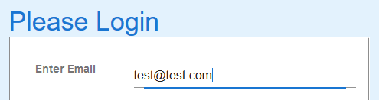

Valid username entered

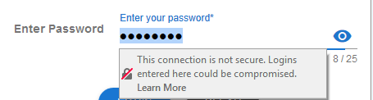

Valid password entered and submit button clicked

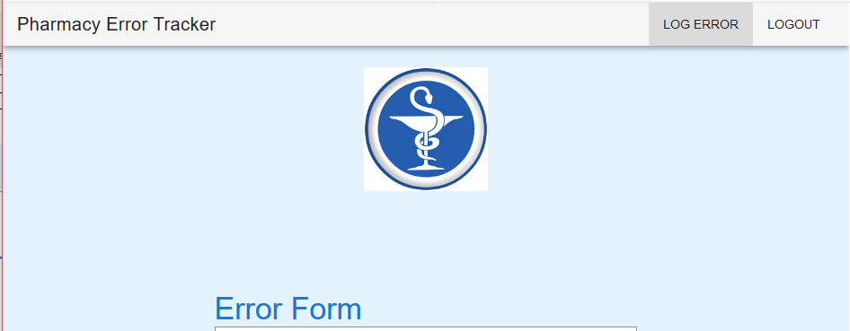

Correct form is presented with only Log Error and Logout buttons available in the menu bar.

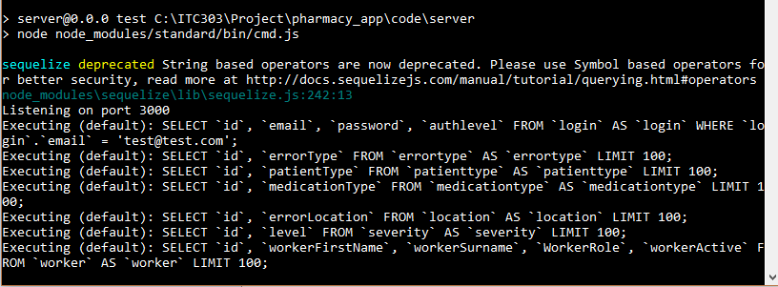

Server showing no error after [test@test.com](mailto:test@test.com) successfully logged in

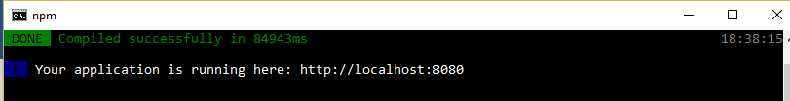

Client showing no error after [test@test.com](mailto:test@test.com) successfully logged in

Logout button returns user to the Login Page

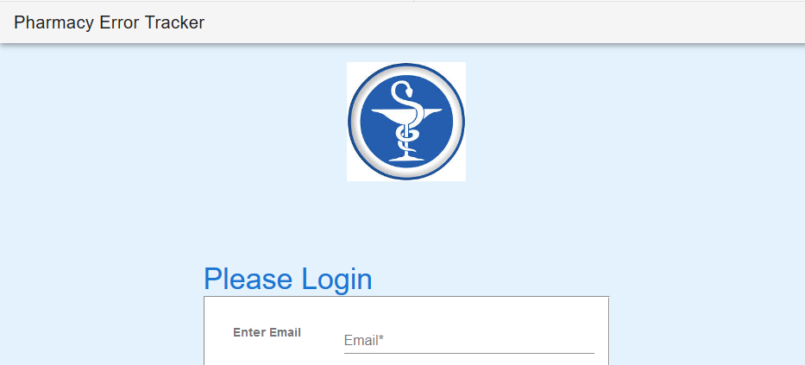

Test 2

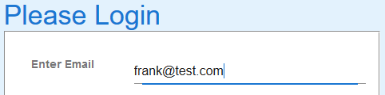

Valid username entered

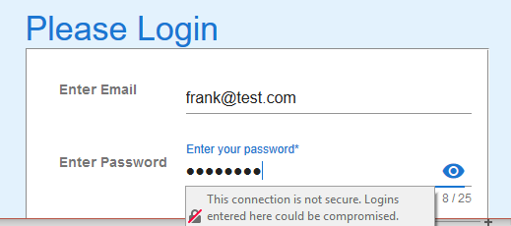

Valid password entered and submit button clicked

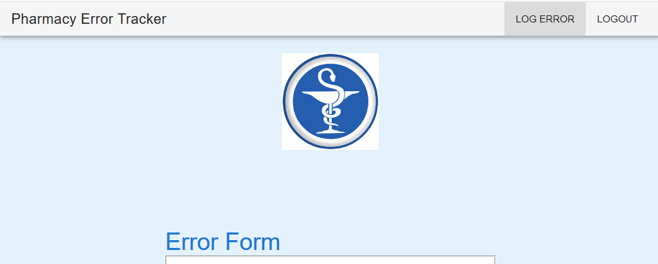

Correct form is presented with only Log Error and Logout buttons available in the menu bar.

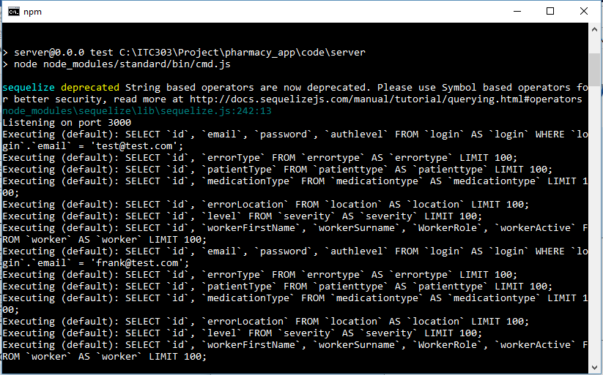

Command window showing no errors after user [frank@test.com](mailto:frank@test.com) successfully logged in.



Client showing no error after [frank@test.com](mailto:frank@test.com) successfully logged in

Log messages on the PET app after the two tests have been performed:

